Magmatifc sedimentation and carbonatitic brentiation in kimberlite sills at Benfontein, South Africa
JOHN BARRY DAWSON & JOHN BARRY HAWTHORNE

CONTENTS
- Introduction ......
- Location and field relationships .
- Kimberlite petrography ....
- Structures in the sills .....
- Metamorphism of xenoliths and wall-rock
- Petrochemistry ......
- Conclusions . ...
- References .
SUMMARY
61 62
65 72 76
77 81
83

At Benfontein, near Kimberley, South Africa, three sills of kimberlite intrude Dwyka shales and overlying Karroo dolerite. Each sill results from numerous injections of kimberlite that have consolidated to give the sill a layered appearance. Many layers - show magmatic sedimentation features and cumulus textures, and, although some show in situ differentiation, other layers result from pre-injection differentiations The transporting, intercumulus liquid was carbonate-rich and some layers have differentiated to form a carbonate rock composed of the intercumulus calcite; this, on trace element and isotopic data, shows strong affinities with carbonatite. In one of the sills 'one calcite layer has migrated diapirically into overlying layers in.the sill. These sedi-
mentation features, combined with thermal metamorphism of country-rock shales and the presence of quench calcite and apatite, are interpreted as evidence that the kimberlite was injected as a highly mobile fluid, comprising megacrysts of olivine, garnet, pyroxene, mica and picroilmenite in a hot carbonatitic liquid from which olivine, magnetic spinel, perov-skite, apatite, calcite, dolomite, ankerite and quartz crystallised. The evidence that the transportation medium was a warm carbonatitic liquid is directly opposed to earlier hypotheses proposing that kimberlite is intruded as a cold or plastic paste, and also supports proposals of a genetic link between kimberlite and carbonatite.

1. Introduction
Kimberlite is a rare ultrabasic igneous rock-type that occurs mainly in diatremes and dykes and, much more rarely, in sills. The comparative rarity of sills is due, in part, to the fact that the present-day erosion level in areas of low relief must coincide with the injection level of these thin, horizontal bodies. Nonetheless, several kimberlite sills were reported in the Kimberley area of South Africa in the early part of this century (Voit 1907; Wagner 1914), and others are known in Rhodesia (Macgregor et al. 1937), in the Singida area of (Williams 1930) and in S.W. Greenland (Andrews and Emelens to7i).

6г J. В. Dawson & J. В. Hawthorne
Diamond prospecting operations since 1955 by the Geological Division of De Beers Consolidated Mines Ltd., have led to the discovery of several new kimberlite sills in the areas north-west and south-east of Kimberley (Hawthorne 1968). The purpose of the present paper is to enlarge upon the preliminary account i' of one of these sills, at Benfontein, 8 km south-east of Kimberley. Hawthorne (op. cit.) had recognized the possibility of there being more than one sill at Benfontein, and a further intriguing feature was that the locality had been listed as a possible carbonatite by Verwoerd (1966). Following a brief visit to Benfontein in October, 1966, the first author (J. B. D.) recognized, in a small collection of specimens gathered during the visit, magmatic sedimentation structures that had not been previously recorded in kimberlite (Dawson & Hawthorne 1970). Further detailed mapping by the authors in the period September 1969 to August 1970, with confirmatory pitting, trenching and percussion drilling, has confirmed that the sill is a sill-complex or area of relatively intense and complicated sill intrusion. In addition, a wider variety of sedimentation structures has been found, including good examples of layering, graded bedding, cross-lamination and load-cast structures. Segregation in some units has given rise to carbonate-rich layers which have migrated diapirically within the units. These features, combined with thermal metamorphism of the country-rock shales, are interpreted as indicating that the kimberlite was intruded as a high-temperature liquid.
2. Location and field relationships
The kimberlite sill-complex occurs some 8 km south-east of Kimberley on the farms Dutoitspan 422, Uitzicht 124 and Benaaudheidsfontein 442, collectively known as Benfontein. The sill-complex lies on the important zone of major kimberlite diatremes that strikes NW-SE through Kimberley (Fig. 1).
The main sill-complex crops out on undulating high ground astride the Kimberley-Petrusberg road, the best exposures being on slopes overlooking a small inland drainage area—the Benfontein Pan. Small outcrops have been also found between the main road and the railway, to the north-east of the main outcrop, and also to the north of the railway line. In all, outcrops have been found over an area of 4J km east-west and i\ km north-south and another small area of loose kimberlite "float" has also been found 5 km south of the main area.
The country-rocks are black and grey shales of the upper Dwyka Series (Upper Carboniferous) that are intruded by a major sill of Karroo dolerite (Jurassic). This particular Karroo dolerite sill in the Kimberley area has been traced over an area of about 13 000 km² (du Toit 1906) and is referred to as the Kimberley Sheet. Its contact with the underlying shales is not a simple planar surface since smaller intrusive stringers and associated minor sills inject the shales below the main contact; in addition, large tabular raft-like xenoliths of shale occur in the
Magmatic sedimentation and carbonatitic differentiation in kimberlite sills 63
acting in the role of a 'cap-rock' to the intrusive kimberlite (Hawthorne 1968).
Combined with a sometimes poof exposure due to the superficial cover of calcrete
and/or sand, the interstratified shales, dolerite and kimberlite give an apparently
complex and confusing, succession and outcrop pattern (Fig. 2); these are,
however, produced by the simple injection sequence illustrated diagrammatically
in Fig. 3.
, Hawthorne (in press) has estimated that sediment and lava in the order of \ 1600 m has been eroded from the Kimberley area since the intrusion of the ! kimberlite and this would have been the depth of cover over the sill at the time of the injection.
The mapping has outlined three main members of the sill-complex, the Upper, Middle and Lower Sills, with many minor veinlets. The Upper Sill lies to the north of the road and on the upper and middle slopes of Trig. Beacon Hill, extending south-eastwards to form a prominent ridge feature to the east of the old enclosure and cropping out in the stream that bounds the sill-complex on its
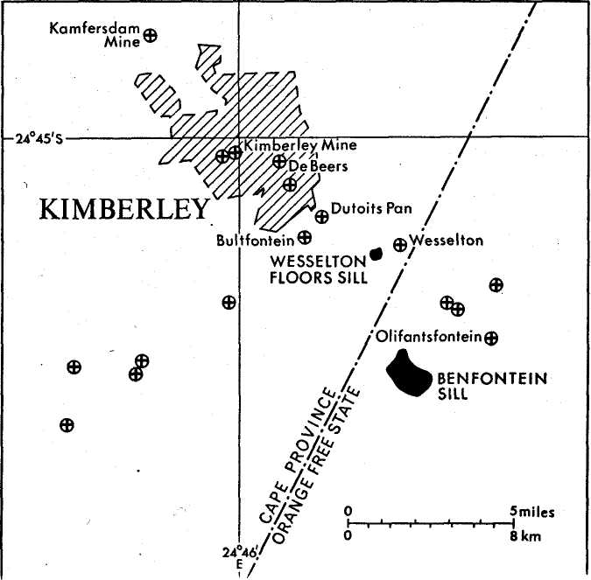

/
\
уЧ^
/,
/////*&-/£>
<2>
Ъ2>

 | Sand and calcrete
ш | Kimberlite
Hiiiiii | Oolerit* Shal*
 | Area of dolerlte highly
Шт | Intruded by kimberlite
 | Road Railway
___ | Truck
А | Trigonometrical point
 | Approximate contours
 | Trench
■ | Pit

_| S#cf.i
ion I in*

-X
^ «-_««№№_

iBEACO

\
\
V
X.
.и* \

■4
(Той Г?

\
\
ПО 200 300т
50 500 750 1000(1
^^{А}_
Old / /
•ncloti/r» .• "'..i

НЮ. BEACON Hill

Magmatic sedimentation and carbonatitic differentiation in kimberlite sills 65
southern side, Dolerite is the roof-rock in the central part of the outcrop whereas in the western and eastern parts^itTs shale. Exposure is not sufficiently good to determine whether this is due to greater upward penetration of the sill in the central area or whether a shallow antclinal (? domal) structure could be inferred, although in the eastern part there is decided eastward dip (E.N.E.) at 14⁰ in Pit 2. The sill is particularly strongly interstratified with shale and dolerite on the slopes of Trig. Beacon Hill and, in the area immediately north of Trench D, kimberlite comprises not more than 30% of the succession. Estimates of the thickness of kimberlite on Trig. Beacon Hill are consequently unreliable but it is believed to be not less than 5 m. Other thicknesses are at Trench D—at least 2*5 m of kimberlite, Pit 3-6 m and Pit 2-2*25 m. There is no evidence of thinning in any particular direction.
The Middle Sill crops out in an arcuate band and has a general thickness of 1-5 to 2 m, with no apparent thinning in any given direction. Like the Upper Sill, there is a gentle dip to the east or north-east.
The Lower Sill crops out sporadically on the slopes below the quarry; the dips are highly variable due to the conformity of the sill with the country-rock shales which have been contorted by_expansion due surface weathering. A maximum thickness of o-6 m is seerTin outcrops, and the sill has also been exposed in Trenches A and В where it has a maximum thickness of 0'8 m with a more general thickness in the order of о*25-о*з m. Two ^boreholes sunk through the Middle Sill at Trench С and near the quarry did not intersect the Lower Sill. This, combined with the evidence from a series of shallow boreholes (varying from 6 to 45 km deep) north and east of Trenches A and B, indicates that the sill at this point is a narrow, tongue-like body, striking N.N.W.-E.S.E. and pinching out to the east, approximately 25 m east of Trench B: it may have extended further to the south, prior to erosion.
The scattered outcrops to the north-east of the main outcrop are generally not greater than 1 m thick, and the two most easterly outcrops are thin 0-15 m stringers in the dolerite exposed in a railway cutting and an irrigation ditch north of the railway.
In most cases the contact of the hard kimberlite with the dolerite and shale (the latter generally converted to hornstone) is sharp. However at the lower contact of the Middle Sill in Trench G the hard kimberlite is separated from the underlying shale (not hornstone) by a 0-5 m zone of yellow, decomposed kimberlite. Similar decomposed kimberlite has also been found at the^base of the Upper Sill in Pit 3 and sporadically at the upper contact of the Lower Sill in Trench A.
3. Kimberlite petrography
(a) field petrography The Benfontein kimberlite is unusual in that it crops out as a hard rock; exposed
66 J. В. Dawson & J. В. Hawthorne
the kimberlite is highly variable due to a variety of structures and textures described below. Generally the rock has a rough texture due to megacrysts of olivine weathering out of the dark matrix. (The term "megacrysts" will be used throughout in general descriptions since both xenocrysts and phenocrysts are present.) Minute, weathered-out crystals of apatite are also sometimes visible. The olivine megacrysts may be up to 6 mm in size, the largest being found in the Upper and Middle Sills. Where fresh, the megacrysts are light-green in colour, or orange-brown with a black rim where serpentinised; serpentinisation is general in the Upper and Lower Sills, whereas olivine in the* Middle Sill is comparatively fresh. The megacrysts may be xenomorphic or idiomorphic, some idiomorphic crystals having perfect morphology. The megacrysts: matrix ratio is highly variable from a ratio of 70:30 to virtually aphyric, fine-grained aphyric varieties often being found at the contacts or around xenoliths.
In addition to the kimberlite, which has an overall black appearance, there are near the upper contacts of the sills, and at various horizons within the kimberlite, white calcite-rich layers; these vary from 5 mm to 20 cm thick, and are thickest near the upper contacts of the Upper and Middle Sills. The layers are not persistent horizontally, varying from lenticles up to 5 m long to small trough-shaped channels (in⁴⁴ the border of 4-5 cm wide) within the kimberlite. The groundmass is granular or fine-grained and in some cases, there is a superimposed network of acicular, randomly-oriented calcite crystals. The larger layers" commonly contain rafted xenoliths of shale.
The sills are also cut by numerous vertical and horizontal veins of fibrous calcite; these veins are up to 10 cm thick and infill joints and shrinkage cracks within the kimberlite.
(в) MICROSCOPIC PETROGRAPHY
In thin section it is evident that most of the kimberlite is a rock with cumulate texture. The cumulus grains are the megacrysts of olivine and rarer phlogopite, and also the much smaller crystals of opaque spinel (s.l.), perovskite and apatite. The intercumulus liquid has crystallized mainly as calcite, with minor patches of isotropic serpophite and rare, randomly-oriented crystals of a second generation of phlogophite. All the cumulus crystals and the intercumulus material vary widely in their modal proportions.
The olivine megacrysts range from o*5-6 mm, and sorting is generally poor; they show every transition from fresh to completely serpentinised and carbonated. On the basis of their morphology, four groups of olivine megacrysts can be recognised:
(i) Idiomorphic olivines, some with perfect morphology (Plate iA). A very few show slight marginal optic zonation, which probably would be obliterated by even the slightest degree of serpentinisation. It is evident that these olivines have suffered neither chemical nor mechanical corrosion.
d'i) Rounded composite granules of inequigranular idiomorphic olivines,
Magmatic sedimentation and carbonatitic differentiation in kimberlite sills 67
strained and show undulose extinction. Some olivines are covered by a thin black coating of perovskite.
(iv) Rounded aggregates of xenomorphic granular or xenomorphic inequi-granular olivine (Plate iB, C); light-brown mica is a common minor constituent in these aggregates (Plate iD) which have every appearance of being micro-xenoliths of dunite or fragments of the larger peridotitic blocks commonly found in kimberlite.
Group (iii) and (iv) megacrysts are often serpentinised whereas the group (i) and (ii) megacrysts in the same section may be fresh, the implication being either (a) the corroded or serpentinised megacrysts were altered ex situ before transportation and deposition within the sill; or (b) they are less stable in the sill environment than the fresh megacrysts. A further inference is that the former are xenoliths and xenocrysts, whilst the latter are phenocrysts and cognate xenoliths, although it should perphaps be stressed that our division has been made on the basis of crystallographic perfection, and even the idiomorphic crystals may be completely replaced by serpentine or, in the Lower Sill, by calcite or ankerite. It may be significant that two groups or generations of olivine have been found in Other South African kimberlites, the different generations being recognized on grounds of contrasting morphology and alteration (Wagner 1914, p. 54; Dawson 1962a) or differing iron content (Nixon et al. 1963). In the case of the Benfontein olivines, a further suggestion of two generations is given by the fact that, whereas the xenomorphic crystals are free of inclusions, the idiomorphic megacrysts sometimes contain inclusions of spinel or picroilmenite (Table 2). Microprobe analyses of the olivines, however, suggest that this subdivision is an oversimplification. On the basis of the data in Table 1, the following can be said:

table 1: Composition of olivine | megacrysts from Benfontein kimberlite*
Specimen | % Fo in crystal core | % Fo in crystal rim
Idiomorphic olivines
BD 1053, Middle Sill (i) | 881 | 887
BD 1053, Middle Sill (ii) | 893. 87-9 | 89-6
BD 1053, Middle Sill (iii) | 9O-3 | 91-9. 89-5
BD 1053, Middle Sill (iv) | 89-2 | 88-3, 87-5
BD 1053, Middle Sill (v) | 93-b 92-5 | 87-9
BD 1613, Middle Sill | 892 | 879
Xenomorphic olivines
BD1053 | 883, 898 | 849
BD 1613 | 86-1, 87-2 | 897, 89-5
Xenomorphic olivine coated
with perovskite, concentrate
from Pit 2, Upper Sill. | po-8

68 J. B. Dawson & J. В. Hawthorne
(i) The compositional range of the cores of both xenomorphic and idiomorphic olivines is approximately the same, though the xenomorphic crystals tend to be slightly more iron-rich, and variable compositions are found within the cores of individual crystals.
(ii) In both idiomorphic and xenomorphic crystals there is marginal zoning, but in both groups there is evidence of both magnesium and iron enrichment in the rims compared with the cores; this variable marginal enrichment has also been found within idiomorphic crystals from the same rock (BD 1053).
(iii) In both groups of olivine there is sometimes enrichment in calcium and depletion of nickel in the rims.
Our data indicate that, although the morphology and equilibrium state of the idiomorphic olivines appear to indicate that they are a crystallisation product of the kimberlite matrix, the compositional range of the cores is not different from that of olivines that may have been derived from breakup of peridotite xenoliths.
Megacrysts of phlogopite up to 2 mm long are an accessory constituent in most sections of kimberlite from the Upper and Middle Sills, but are very rare' in the Lower Sill. The crystals have pleochroic light-brown to medium-brown-cores with a peripheral bleached zone containing minute octahedral crystals of ? . magnetite; the crystals are strained and marginally corroded, in all these respects resembling the xenocrystal or 'first-generation' phlogopite of other kimberlites (c.f. Dawson 1962a, p. 550).
In addition to the olivine and mica megacrysts, crystals of pyrope garnet, picroilmenite up to 4 mm in size, chrome diopside and diamond have been recorded from kimberlite concentrates from Pits 1, 2, 3 and 4. The garnets are either purple-red or orange-brown in colour, and analysis of one of the purple-red variety shows it to be a high-chrome pyrope (Table 2). The ilmenites are rounded and have the conchoidal fracture typical of kimberlite ilmenites; the analysis of one grain shows it to be a high-magnesium ilmenite (Table 2).
The smaller cumulus minerals are opaque spinel, perovskite and apatite. The spinel is present in sufficient quantities to make the rock magnetic and occurs as octahedra up to 0-15 mm, or twinned crystals or aggregates up to 0.4 mm (Plate 2A); in some instances it may be intergrown with perovskite. Individual crystals may show peripheral indentations and examination in reflected light reveals extensive peripheral replacement by a non-reflecting mineral that is very dark-brown in transmitted light. In some specimens, the peripherally altered area is overgrown by a later sheath of opaque mineral with the same reflectivity as the core. Microprobe analyses of the spinel (Table 2) show it to be a solid solution mainly of magnesian iilvospinel, magnesioferrite and spinel (s.s.) (Table 2A). The perovskite is a ubiquitous phase, in dark brown cubes up to o*i mm, some with interpenetrating twins. The apatite is present mainly as stubby prisms up to o-i mm, but in one specimen from the Upper Sill, are acicular apatite crystals up to o-8 mm long in sheaf-like aggregates within patches of relatively coarse calcite (plate 2B).
Magmatic sedimentation and carbonatitic differentiation in kimberlite sills 69

TABLE 2: | Microprobe analyses of garnet and opaque |  |  | oxides from | the Benfontein sills
 | 1 | 2 | 3 | 4 | 5 | 6
SiO₂ | 41-3 |  |  | 2-4 | O-IO | 097
TiO_{a} | — | 53-9 | 56-3 | 21-5 | 18-o | 22-6
Al₂O_{a} | 20-2 | 0-42 | 037 | 7-4 | 7-8 | 8-O
Cr₂O₃ | 5,1 | 2-4 | 1,5 | 1-4 | 0,06 | O,l8
FeO* | 6,9 | 26-3 | 27-9 | 52-2 | 58,6 | 51,5
MnO | 0-41 | o-33 | n.d. | 0,63 | 073 | O,6o
MgO | 19-9 | 14-4 | 138 | 14,9 | 13-4 | 15-2
NiO | 0-05 | 0-19 | n.d. | — | — | —
CaO | 5-3 | — | — ■ | O,11 | 0-13 | O-2O
NagO | о-об | . — | — | — | — | —
 | 99'22 | 97,09 | 99,98 | 100,54 | 98,82 | 99,25
* All iron expressed as FeO. ,
- Purple-red chrome-pyrope from concentrates, Pit 2. Analyst: С. Н. Emeleus.
- Picroilmenitc from concentrate, Pit 3. Analyst: G. H. Emeleus. (Normative composition:
ilmenite 43-5%, geikielite 49-3%, pyrophanite 0-5%, NiTiO₈ o-2%, haematite 3-6%, eskolaite
2-2%, corundum 0-5%).
- Picroilmenite inclusion in idiomorphic olivine, specimen BD 1613, Middle Sill. Analyst:
R. Hutchison. (Normative composition: ilmenite 49-6%, geikielite 46-8%, haematite i-8%,
eskolaite 1-3%, corundum 0-4%).
4-6. Cumulus magnetic opaque spinel in kimberlite BD 1617, Lower Sill. Analyst: С. Н. Emeleus.
table 2a: Structural formulae (assuming stoichimetry) and end-member analyses of
opaque spinels in Table 2

Si Ti Al Cr  Fe«- | 0-076 0-511 0275 0035 0-516 | 0-003 0-439 0-298  0-002  0-816 | ОЮ31  O-543 O-3OO O-0O5  0547 | Spinel Jacobsite Chromite Olvospinel Titano-spinel Magnesio-lemte | MgAl₂O₄ MnAl₂O₄ FeCr₂O₄ FejTiO,, Mg₂TiO₄ | 138  i-7 i-8  42-3 8-8 | »4'9  2-0 O-I 38-5  54 | 150  2-O  о-з  41-3 13-0
Fe»+ | 0864 | 0-772 | 0828 |  | MgFejO₄ | 24-1 | 388 | 258
Mn Mg Ca | 0-017 0-702 0-007 | 0-02O 0-646 0-004 | o-o 16 0-723 0-007 | Silicates |  | 7-6 | 03 | 31

76 J. В. Dawson & J. В. Hawthorne
in addition to crystals of the smaller cumulus phases. Other poikilitic crystals, with random orientation and poorly defined faces, are up to 5 mm long and platy, having length:breadth ratios of 10:1. In other specimens the intercumulus calcite has a tabular habit.
In many specimens are small rounded patches, up to 2 mm in size, which are composed solely of the intercumulus calcite; in these cases the morphology of the calcite within these spherules is the same as that of the intercumulus calcite in the immediate vicinity of the segregation, whether xenomorphic or prismatic. A different morphology is shown by calcite crystals that are sphenoid or prismatic in section and that occur as microphenocrysts in fine-grained postcumulus calcite; there may be either randomly oriented or else strongly oriented to form a trachytic texture round olivine megacrysts (Plate 3A). Because of their morphologic and size contrast with the intercumulus calcite, the possibility cannot be excluded that these crystals may be pseudomorphs after some less stable CaCO_{a} phase (e.g. aragonite or vaterite) or some easily calcitized phase such as portlandite or melilite. It has been suggested, on both the grounds of bulk rock chemistry, replacement textures, and the close field relationship between kimberlite, olivine melilite and alnoite, that melilite may have been an original phase in many kimberlites, prior to carbonation and hydration (Shand 1934; Dawson 1967). Replacement of melilite to give lath-shaped calcite has been shown in kimberlite and alnoite dykes in Sweden (von Eckermann 1961,1967) and has been postulated in the case of alvikite dykes in the Ruri carbonatite complex in Kenya (McCall 1963); melilite was also believed to be a primary mineral in the now highly calcified dykes and flows of the Qagssiarssuk complex, South Greenland (Stewart 1970). In the last two cases, morphology of the calcite crystals alone was the sole criterion for postulating earlier melilite. In the case of Benfontein, no relict cores of an earlier phase have been found, optical and X-ray diffraction tests revealing only calcite. Therefore the possibility of pseudomorphism can be no more than a suggestion, again based on the morphology. Alternatively, the calcite morphology may be primary, and comparison may be made with the tabular calcite phenocrysts, set in a 'microgranular granoblastic mesostasis of calcite, dolomite and apatite', that are recorded in a trachytic textured carbonatite dyke in the Meimeich-Kotui area of Siberia (Zhabin & Cherepvskaya 1965), and pseudohexagonal phenocrystal plates (prismatic in section) of complex alkali carbonate occurring in the alkali carbonate matrix of the modern carbonatite flows on the volcano Oldoinyo Lengai, Tanzania (Dawson 1962b). In addition, the carbonate pheno-cryst/matrix relationship has its analogies in the dolomite phenocrysts in the beforsite of the Dorowa and Shawa carbonatites, Rhodesia (Johnson 1961), and has been observed in quenched synthetic carbonatite melts (Wyllie & Tuttle i960; Gittins 1963). Galcite of yet another different morphology is found in some of the carbonate layers of the Lower Sill. Generally the calcite is equigranular consisting of a fine-grained matrix containing prismatic or sphenoid micro-pbrnocrvsts similar to those noted above, but in some layers are slender platy
Magmatic sedimentation and carbonatitic differentiation in kimberlite sills 71
columnar aggregates of dendritic crystals (Plate 3B) similar to these described from the Oka carbonatite complex, Canada (Girault 1966, Fig. 3), These columnar aggregates are generally randomly oriented and, in some instances, the interstices between the aggregates consist of single crystals of biaxial calcite.
Although randomly oriented dendritic or skeletal calcite are found in the Lower Sill, strongly oriented dendritic crystals are found in all three sills, occurring at layer contacts, and growing approximately normal to the contact and into the later-injected layer. Most commonly they grow downward from the upper contact of a layer, but occasionally upward from the lower contact. The dendrites, that are generally not greater than 10 mm long, may initially grow as single filaments or alternatively bifurcate immediately into two filaments at the nucleation surface (the contact). Each filament tends to be simple for approximately 4-5 mm from the contact at which point bifurcation and/or parallel growth may occur (Plate 3C). Sometimes the dendrites are slightly curved, the curvature in any specimen always being in the same sense. These contact dendrites are particularly well developed in layers that are relatively poor in olivine, especially in spinel-perovskite accumulate layers or layers with a high-proportion of intercumulus calcite (Plate 6D). In some of the carbonate-rich layers in the Lower Sill, randomly oriented dendrites and contact dendrites may occur within the same layer. The dendritic calcites are texturally similar to the dendritic 'Willow Lake' or 'crescumulate' textures exhibited by olivine, clinopyroxenes and plagioclase in some basic layered intrusions, (e.g. Taubeneck & Poldervaart i960; Wager & Brown 1968), and also similar to the dendritic textures observed in alloys (e.g. Saratovkin 1950). In these examples, the texture is attributed to rapid crystallisation due to undercooling of a melt that is saturated with respect to the ^dendritically precipitated phase. The Benfontein calcite dendrites are likewise interpreted as a quench product, as the layers in which they are found are undoubtedly rich in calcite and many grow from an obvious cooling surface. Calcite dendrites produced in the synthetic system CaO-CO₂-H₂O are regarded as positive evidence for the former existence of a liquid phase (Wyllie & Boettcher 1969), and during work on the system CaO—CaF_{g}—P₂O₈—CO₂—H₂O (Wyllie et al. 1962) apatite precipitated from the liquid phase during a quench formed acicular prisms clustered in sheaf-like form. The analogy between the experimentally produced calcites and apatites and the natural minerals at Benfontein is very strong. Combined with the evidence of the cumulate texture and the magmatic sedimentation features to be described later, these textures are strong proof that the transporting medium, that finally consolidated mainly as the intercumulus calcite, was liquid rather than gas.
Compared with the calcite, the other two postcumulus phase—phlogopite and serpophite—are volumetrically insignificant. The mica is in colourless, randomly-oriented plates up to 0-5 mm long (Plate 2D). Although it is a relatively rare constituent in most specimens, it does compose some 20 per cent of the thin kimberlite vein cropping out north of the railway (Fig. 2). The serpophite is in
7* J. В. Dawson & J. В. Hawthorne
Petrographically, the kimberlite at Benfontein differs in certain aspects from what is generally regarded as 'normal' kimberlite. There is an absence of the large xenoliths of deep-seated rock-types such as garnet lherzolite and eclogite; and large megacrysts of phlogopite, picro-ilmenite and garnet are rare. This may be due to the exposed section of the sill-complex being situated at some distance from its feeder-dyke, since it might be expected that sedimentation of the large xenoliths and high-density xenocrysts would commence close to the point where flow changed from vertical to horizontal (i.e. close to the junction between dyke and sill). Conversely, light material such as phlogopite may be preferentially transported and the high mica content in the most easterly exposure (p. 15) is pertinent in this context.
4. Structures in the sills
Layering is the most conspicuous structure both in the field and in thin section. The individual layers are thin—generally in the order of 2-6 cm, though calcite-rich layers in particular tend to be thicker and may be up to 20 cm thick. In terms of the definitions proposed by Jackson (1967) the following types of layers have been recognised:
(i) Isomodal layers, in which the proportions of olivine, spinel and perovskite remain constant both to each other and to the intercumulus calcite. Olivine cumulates, olivine-spinel-perovskite cumulates, spinel-perovskite-olivine cumulates and spinel-perovskite cumulates are all present, the last being particularly dense. There are also isomodal layers of calcite.
(ii) Mineral-graded layers, in which there is a systematic change in the ratio of olivine to spinel + perovskite (Plate 4A). In some there is also an increase in the proportion of postcumulus calcite towards the top of the layer and in some cases the top of a graded layer may be pure calcite that is the result of gravity differentiation.
(iii) Size-graded layers are rare but are present in the Middle Sill. One specimen (BD 1655 from 90 m east of the quarry) is 5-5 cm thick. At the base the olivines are on average 1-5-2-0 mm (range 0-3-3-0 mm) and grade to an average of 0-75 (range 0-2-1-3 mm) at the top (Plate 5A). Despite the fact that there is an overall grading, sorting is poor and the nearest equivalent structure in sedi-mentological terms would be termed 'delayed grading with poor separation' (c.f. Dzulynski & Walton 1965 p. 171). This layer is also mineral graded, with spinel and perovskite increasingly abundant in the upper part. Further evidence, of a different nature, for in situ settling has been found in another specimen from the Middle Sill (specimen BD 1613). This specimen, again poorly sorted, contains some exceptionally large olivine megacrysts (up to 6 mm). Below some of these megacrysts, and particularly below platy megacrysts are concentrations of the cninr-1 алН perovskite that are otherwise more sparsely distributed throughout the
Magmatic sedimentation and carbonatitic differentiation in kimberlite sills 73
slowly settling perovskite and spinel beneath the megacrysts. The spinel -f perovskite concentrations have not been found below small rounded olivine crystals, nor even below large crystals that do not possess a large, planar, downward-facing surface.
In addition to grading, other structures are found within individual layers. Cross lamination is a conspicuous feature both in the field and in thin section (Plate 5B), and microtrough cross-lamination is present in some calcite-rich layers (Plate 4G). Platy lamination is sometimes present in olivine cumulate layers that contain prismatic olivines oriented parallel to the layering.
Contacts between layers are commonly ratio contacts but there are also phase contacts, particularly good examples of the latter being the spinel-perovskite cumulates .and the calcite layers (Plate 6D). It is interpreted that the layers bounded by phase contacts, containing within them high concentrations of phases that are normally more evenly distributed throughout the kimberlite, must result from pre-injection concentration of these phases by some type of differentiation. Contacts are sometimes planar (Plates 4A, B) but also irregular with localised unconformity, and there are good examples in all three sills of truncation of earlier layering by later-injected material (Plate 4D): this is particularly spectacular in the case of later-injected calcite layers due to the colour contrast. Disruption of layering may also be caused by loading of less dense layers by overlying layers rich in spinel and perovskite (Plate 8A).
One of the most interesting structures is found in the upper part of the Lower
Sill, where there is a zone of miniature diapiric structures; these are illustrated in
Plates 6A-D. They occur above a zone characterised by a general presence of
large amounts of intercumulus calcite, and are directly connected with a gravity
differentiated layer, the top of which consists mainly of creamy prismatic calcite
with minor amounts of serpentine and spinel. This calcite concentration has been
* superimposed on a thin zone already characterised by calcite dendrites growing
downwards from the contact with the overlying olivine-spinel-perovskite cumulate
layer. At points along the contact, the differentiated material has broken through
the interface and migrated vertically to form small tubular structures that are
still rooted in the underlying calcite-rich layer; these diapirs are in the order of
0-5-1 cm in diameter and up to 3 cm high. Some diapirs consist mainly of the
creamy calcite + serpentine + magnetite of the root-layer but invariably termi
nate vertically in a lobe of clear rhombohedral carbonate, and some bifurcate
vertically. In other diapirs the lower part may consist of root-layer material with
the upper half of clear carbonate. Others contain sharply-bounded spherules of
clear carbonate within the root-layer material (Plate 7A), the spherules persisting
vertically from the root-layer to the top of the diapir, and yet other diapirs consist
solely of the clear carbonate that can be seen to originate directly within the
extreme upper levels of the root layer. In addition to the diapirs, these are small
independent spherules of calcite (similar to those in the other sills, see p. 11)
within the penetrated layer, where the olivines are replaced by various com-
' ^{г} ..<;.,д ..!.:.„ ,ui.,,,,;*«,,,j ^,,i._{Pr};tr. Above the laver penetrated
74 J> В. Dawson & J. В. Hawthorne
mainly of clear carbonate. Many occur vertically above the rooted diapirs and, although only in a few instances (e.g. Plate 6D) are there examples of these bodies breaking through the interface between the two layers (possibly due to lack of the third dimension in thin section), it is evident that these bodies were originally part of the rooted diapirs but became detached during vertical migration. This is confirmed by distinctive similarities in mineralogy between the amygdale-like bodies, and the clear carbonate diapirs and spherules in the predominantly root-layer material diapirs; hence these amygdale-like bodies are referred to as 'detached diapirs'. The detached diapirs are generally elongated vertically, often bifurcating upwards (in contrast to true gas cavities and amygdales); the bifurcation often takes place around earlier vertical dendrites (Plate 7C). They may also be rounded and, in a few cases, elongated horizontally where the diapir has spread laterally beneath an overlying competent layer (Plate 6D).
Like the clear areas in the rooted diapirs, the detached diapirs consist mainly of large patches of clear rhombohedral calcite; in some instances, the rhombohedra appear to have replaced earlier aggregates of platy calcite, the morphology of which is still visible due to the continued presence of the dusty elongate lines of minute inclusions that formerly mantled the calcite plates (Plate 7G). Some diapirs are roughly zoned with a thin outer rim of dolomite and a core of calcite and/or ankerite. Within the calcite/ankerite areas are small rhombs of dolomite, occasional crystals of rhombohedral quartz (the shape presumably being dictated by the surrounding carbonate rhombs) (Plate 7C) and, quite commonly, large octahedra of magnetite showing (1 n) twinning (Plate 7D). An implication of the zoning is that crystallisation took place after movement of the fluid diapir had ceased. In addition, rare acicular quartz crystals grow into the carbonate from the wall of the diapir. Serpentine and chlorite are accessory minerals in some diapirs, and some of the larger detached diapirs have a vuggy structure, the core being unoccupied. Others have a chalcedony lining and a vuggy core. The contrast in mineralogy of these diapirs and spherules with the other kimberlite carbonate areas is of particular interest, especially the presence of free silica in the form of quartz and chalcedony.
It has been shown earlier that concentration of calcite has been effected in other layers but without the diapiric structures found in the Lower Sill. What are the peculiar features in this zone of the Lower Sill that leads to the diapirism? First, a relatively warm, very fluid layer rich in calcite is in contact with an overlying, relatively cool layer; there are obvious differences in viscosity and density (one tested calcite layer having a density of only 2-72). Second, in all complete sections examined the zone of diapirs is overlain by an even denser layer (density 3-38), rich in spinel and perovskite, which has caused loading of the underlying layers. This is particularly evident when the loading has caused contortion of the layers (Plate 8A). It has been shown experimentally that diapiric structures (some with a tendency to bifurcate upwards) can be caused by settling sand on soft clay (Dzulynski & Walton 1965, Fig. 151), the structures being attributed to
!•"• ....,.„ tb ' ■' • ' 1 . ,i:rr :.. • •■ "• :i.
Magmatic sedimentation and carbonatitic differentiation in kimberlite sills 75
1970). By analogy, it is suggested that a combination of contrasts in density and viscosity was responsible for the diapiric structures at Benfontein. The overloading caused by the spinel-rich layer suggests that density contrasts are the dominant factor, and a comparison of the idealized profile of a viscous mass extruded through a central hole due to the weight of an overlying plastic plate (Ramberg 1970, Fig. 3) with an actual example from Benfontein is particularly instructive in this context (Fig. 4; Plate 8B). In addition, there must have been differences in temperature between the calcite layer and the overlying penetrated layers, as witnessed by the growth of dendrites at the contact. However, although there must have been sufficient prior cooling in the upper layer to have permitted it to act as a cooling surface against the calcite rich layer, it was nonetheless still sufficiently hot to remain viscous and permit penetration from below; this is particularly evident when the pentrated layer was sufficiently fluid to permit lateral 'drift' of rising detached diapirs (Plate 6D). Hence it appears that the thermal contrast may not have contributed as much as the density and viscosity contrasts to the diapiric rise.
Whilst it is possible to attribute the origin of the rooted diapirs principally to the effect of loading or density contrast, in the case of the detached diapirs it appears in view of their obvious greater mobility that the viscosity factor may have been greater. With reference to the actual formation of the detached diapirs, it has been stated above.that they resemble amygdales. In that they contain a high proportion of calcite (the 'groundmass' material in the kimberlite), are zoned and may have a vuggy core, the detached diapirs superficially resemble the so-called 'segregation vesicles' found in dykes and flows of basic and intermediate composition (Smith 1967). These segregation vesicles are believed to be initiated by gas causing a sub-spheroidal or sub-ellipsoidal cavity; this is later infilled by residual melt that forms a lining to the cavity (often with trachytic texture), with "subsequent zones of hydrothermal minerals and a vuggy core. In the view of Smith (op. cit.) and Mackenzie & White (1970) segregation vesicles may be misinterpreted as globules of immiscible liquid.

(a)
(b)

76' J. В. Dawson & J. В. Hawthorne
Although superficially resembling segregation amygdales the detached diapirs at Benfontein differ from them fundamentally because the immediate lining of the diapirs is dolomite, not calcite (the main intercumulus phase), and the material in filling them can be traced back into the root-layer.
It is evident that the clear carbonate spherules and diapirs may originate in the root layer (Plates 6A, B, D; 8B) and that the spherules are sharply separated from the root-layer material (Plate 7A) and contrast chemically with it. The migrating material must have been surrounded by a high-tension surface and consisted most probably of a liquid from which the dolomite, calcite, ankerite, magnetite and quartz precipitated. Whilst not the result of immiscibility in the true sense—i.e. giving rise to two complementary fractions—the results of the separation process are texturally and chemically similar to the products of true immiscibility. This 'immiscible' liquid, of lower viscosity than the material in the root layer where it originates, prior to its consolidation would be capable of faster and more penetrative upward migration.
5. Metamorphism of xenoliths and wall-rock
Country-rock xenoliths are of shale and dolerite. When included in normal kimberlite the shales have been converted to a hard black, splintery hornstone. In some specimens colourless mica plates have developed; in others white spots are developed but these are too fine-grained for the mineralogy to be detected optically and X-ray diffractograms show the presence of only quartz. Shale xenoliths included within carbonate-rich layers are invariably invaded by calcite along their bedding planes, and where ever they are in contact with the intercumulus calcite the xenoliths have developed a thin rim of green fine-grained chlorite. The evidence is that the xenoliths have been subjected to low-grade thermal metamorphism. Further evidence of a thermal contrast between host-rock and xenoliths is seen in Specimen BD 1058 from the Middle Sill; between the kimberlite and the xenoliths is a thin 2 mm zone of intercumulus calcite + apatite, containing no olivine, magnetite or perovskite, which has the appearance of being a thin zone of chilled transporting fluid mantling the xenoliths.
Dolerite xenoliths show no signs of thermal metamorphism but have been metasomatized. Olivine is serpentinised and plagioclase saussuritized up to 4 mm from the contact, though clinopyroxene and ilmenite are unaffected and ophitic texture is preserved; similar effects are described in basaltic xenoliths in Basutoland kimberlites (Dawson 1962). Potassium metasomatism in some specimens is evident from the development of brown anomite mica within the meta-somatised zone.
Induration of country-rock shales have been found at many contacts, and cordierite has been found in hornfels at the upper contact of the Middle and Upper Sills. Extreme caution has been attached to interpreting this as being due to intrusion of the kimberlite, in view of the fact that the rocks have also
' ■ ' 1,.- »!,. '■ ' ' '■ тт. ...„, _{f},_{r} ;„л,„_{nt}j_{nn} _{П}Г olnl,- In, h^n
Magmatic sedimentation and carbonatitic differentiation in kimberlite sills 77
with the growth of new minerals concentrically within the shale xenoliths, is taken as evidence that the kimberlite was injected as a warm fluid. This is consistent with the evidence that other Russian and South African hypabyssal-facies .kimberlites were emplaced at elevated temperatures (Kharkiv 1967; Dawson & Hawthorne 1970).
6. Petrochemistry-Analyses of Benfontein rocks are shown in Table 3, unfortunately Cr_{g}O_{s} is not available for all of the analyses. Analyses 1 and 2 represent what can be regarded as 'normal' kimberlite containing all phases. Compared with average basaltic kimberlite (Dawson 1967) there is a good general agreement except in three respects; the Benfontein samples contain generally higher amounts of CaO and CO_{a}, lower amounts of water and K₂O, and a relatively high ratio of FeO to Fe₂O₈ (this is generally <i in most kimberlites—Dawson 1967). We attribute these differences principally to the fact that the Benfontein kimberlite is a hypabyssal type that consolidated at depth. The intercumulus transporting

 |  | TABLE 3: | Analyses of Benfontein rocks
 | 1 | 2 | 3 | 4 | 5 | 6
SiO_{a} | 25-'9 | 28-63 | 17-54 | 0-52 | 3-17 | 3-4»
TiOg | 1-89 | 1-07 | 434 | o-io | 10-98 | 12-23
AlgO₈ | 2-87 | 2-01 | 501 | 048 | 9-21 | ₇-8t
Cr_{g}O₈ | — | — | — | — | — | O-IO
 | 3-72 | 4-02 | 12-56 | 1-30 | 18-78 | 19-66
FeO | 6-72 | 5-38 | 3-60 | o-6i | 11-04 | 12-12
MnO | -, O-22 | 0-14 | 0-32 | 0-19 | 0-22 | o-43
MgO | 2969 | 34-O2 | 1980 | 8-87 | 14-99 | "•93
CaO | 13-59 | 11-92 | 17-05 | 44-07 | 16-49 | 1745
NagO | 0-01 | O-2O | 0-32 | 041 | O-O4 | 026
KgO | 0-15 | O-O5 | 0-07 | — | _ — | 009
H_{a}O+ | 1-15 | 2-75 | 7-17 | 0-36 | I-90 | 2-34
HgO- | — | 0-23 | 0-87 | 003 | 0-23 | 0-30
P₂O_{e} | 2-2O | 0-27 | 5-n | 1-42 | 1-67 | 2-42
со_{я} | I2-83 | 8-99 | 6-33 | 41-24 | 10-gi | 955
Total | 99-62 | 99-69 | 100-09 | 99-60 | 99-63 | 99-80
- Composite sample of Benfontein kimberlite (Hawthorne, 1968).
- Olivine-magnetite-perovskite cumulate kimberlite, BD 1613, Middle Sill. Analyst: D. G.
Powell.
- Fine-grained, aphyric kimberlite, upper contact of Middle Sill, BD 1621. Analyst: J. R.
Baldwin.
- Calcite-rich layer, BD 1048, Lower sill. Analyst: D. G. Powell, S. G. 2-72.
- Magnetite-perovskite cumulate, BD 1050, Lower sill (Dawson and Hawthorne, 1970).
78 J. В. Dawson & J. В. Hawthorne
calcite, that in the case of diatremes is lost during fluidisation intrusion, has been retained. The high proportion of ferrous iron is partially a reflection of the low degree of serpentinisation of the olivine, a feature noted previously in dykes that do not penetrate to the surface (Dawson 1962a). In addition, Dawson (i960) has noted a strong positive correlation between increased oxidation state of iron and increasing amounts of combined water in kimberlite; the low water content and relatively high FeO/Fe_{a}O₈ ratios of the Benfontein 'normal' kimberlite are in agreement with this observation. The low K₂O content is due to a relative paucity of phlogopite in the Benfontein rocks; in this context, we have already attributed this to preferential transport of micas during horizontal intrusion of kimberlite.
Analysis 3 (Table 3) is of a fine-grained contact kimberlite. Principal chemical differences between it and the 'normal' kimberlite are lower MgO and SiO₂ and higher TiO₂, Al₂Oa iron, GaO and P₂O₆. These features are principally a reflection of the lower proportion of olivine megacrysts, and a concomitant increase in the amount of the finer-grained magnetite, perovskite and apatite.
Analyses 5 and 6 are of spinel-perovskite cumulates, the mineralogy being
reflected in the high TiO₂, A1₂O₈ and iron content; and analysis 6, of a calcite-
rich layer, shows the rock to be composed mainly of magnesian calcite. These
three analyses indicate the chemical extremes that can be derived by pre-injection
differentiation, and it is apparent from the petrography that these extremes can
be expressed mineralogically in terms of four main components—calcite, apatite,
spinel and perovskite. It is also apparent that a magmatic carbonate rock can
be derived by concentration of what is normally a dispersed fraction within the
bulk kimberlite. . •
It has already been established (Dawson 1962a, 1967) that kimberlite is characterised by two contrasting groups of trace elements:
(i) a suite comprising Go, Ni, Cr and Ge in which the elements occur in amounts characteristic of ultrabasic rocks; and (ii) a suite of elements, including Li, B, Sc, V, Gu, Rb, Sr, Y, Zr, Cs, Nb, Ba, La, Та, Pb, Th and U, that occur in greater amounts than is usual for ultrabasic rocks. Selected trace elements have been determined on four Benfontein rocks and are presented in Table 4. Like the Basutoland kimberlites, the 'normal' kimberlite (BD 1613) is characterized by high Ni, and also by high Rb, Sr, Y, Zr, Ba and La relative to ultrabasic rocks. The spinel-perovskite cumulates have a considerably lower Ni content (a reflection of the much reduced amount of olivine), but considerably higher amounts of Sr, Y, Th and U. It is well established that Sr, Y and Th may substitute for Ca in various minerals and, in view of the relative paucity of these elements in the calcite-rich rock BD 1948, it appears possible that they may be accommodated in perovskite and apatite rather than calcite. The high Zr contents may be attributed to the tendency for the element to substitute for Ti which is present in very high amounts in these particular rocks. The trace element content of the calcite-rich rock BD 1048 is of extreme interest for two reasons. First, the high amounts of
^{r}' ^ ^{T} •> i»,rf PI, •■ '■ ■•■' ''■ ■•' •!•'• rnrl- Ьяч ifTinifioq witb rirbonnfite? rntbpr
Magmatic sedimentation and carbonatitic differentiation in kimberlite sills 7-

TABLE 4: |  | Trace | element | content of Benfontein rocks
 | Ni* | Rb | Sr | Y | Zr | Ba | La | Pb | Th | и
BD 1053 'Normal' | 0-15 | 9 | 995 | 4 | 260 | 1295 | 20 | <20 | <20 | 9
kimberlite
BD 1050 Magnetite-^ | O-O3 | 9 | 1345 | 13 | 2245 | 1560 | 20 | <20 | 80 | 23
perovskitc . >
BD 1617 cumulates J | 0-02 | 9 | 1275 | H | 2310 | 1265 | 20 | <2O | 80 | i8
BD 1048 Galcite-rich | O'OI | 5 | 2795 | 3 | 5 | 1480 | 200 |  | <20 | 4
layer
Ultrabasic rocks | O-2 | 2 | 1 | 0 | 3° | 1 | 0 | O-I | O-060-0l6
Basutoland kimberlites | ОЧ4 | 21 | 1140 | 46 | 445 | 740 | 370 | 9 |  | —
* Benfontein data: By X ray fluorescence: Ni in weight %, all other elements in p.p.m. In all Benfontein rocks W and Cu <o-oi%; As, Ag, Au <20 p.p.m.
Analysts: C. van Zyl and С. Б. Feather, Anglo-American Research Laboratories, Johannesburg Data for ultrabasic rocks and Basutoland kimberlites are taken from Dawson (1967b, Tabl< 8.6) except Values for U and Th (Goles, 1967).
carbonatites in which the Zr content is very low or below the levels of detectioi (Johnson 1961; Bowden 1962; Verwoerd 1966). Secondly, the values for Sr Ba, La and Pb underlines the concentrations of these elements in the transporting or intercumulus matrix of the bulk kimberlites.
A further feature of interest is the Th/U ratios. Two of the Benfontein rocks, 'normal' kimberlite (BD 1613) and the calcite-rich layer (BD 1048) have beer independently analysed by delayed neutron analysis in a general study of thi thorium and uranium content of kimberlites (Milledge & Dawson in preparation). The values are respectively: Th 15, 6 p.p.m; U 2-8, 8-7 p.p.m; Th/U 5-4, 0-7. It is apparent that the normal kimberlite and the magnetite/perovskite rock; (Table 4) have Th/U ratios of 4-5, whereas that of the calcite rock is <i. Th/U ratios of <i are extremely rare in igneous rocks, but have been previously found in the carbonatites at Kaiserstuhl, Germany, and in the sodium carbonatite lava.^{c} of Oldoinyo Lengai, Tanzania (Dawson & Gale 1970).
The carbonatitic features of the carbonate fraction are further emphasised by oxygen and carbon isotope data (Table 5). These data are plotted on Fig. 5,
table 5: Oxygen and carbon isotope ratios of carbonate-rich bodies in the Lower Sill

_{S}mow
¹⁸O

BD 1048 Calcite-rich layer
BD 1726 Calcite in detached diapir
BD 1049 Calcite + dolomite from detached diapir
BD 1640/1 Grey coloured carbonate-rich layer containing magnetite
BD 1640/2 Magnetite-rich part of BD 1640/1

9-»3 | -57»
8-73 | -662
4-34 | -287
10-00 | -4-43
 | -fi-fb

8о
J. В. Dawson & J. В. Hawthorne

together with the suggested field of oxygen and carbon isotope ratios of primary igneous carbonatites (Taylor et al. 1967) and also the Oka 'box' containing 88 % of the samples from the Oka carbonatite complex, Canada, that are considered by Conway & Taylor (1969) to have been unaffected by late-magmatic hydrothermal and deuteric processes. The isotope ratios of the two bulk rocks BD 1048 and BD 1640/1, both carbonate layers that were differentiated prior to injection, fall within the Oka 'box' though very close to its boundary. The specimen BD 1640/1 consists of two parts—one in which acicular white calcite is the dominant mineral, (BD 1640/3) and, the other part consisting of equi-granular calcite with small patches of haematite (BD 1640/2); the latter appears to have recrystallised. BD 1640/3 falls within the angle formed by the Oka 'box' and the probable field of primary igneous carbonatite, in an area which may be reasonably regarded as an extension of the field of primary carbonatites. The weathered portion of the specimen (BD 1640/2) falls away from the primary carbonatite field; however, like many calcites from unaltered Oka specimens (Conway & Taylor 1969) it is deviant only in oxygen. Calcite samples from two detached diapirs were also analysed. Sample BD 1726 lies closest of all the Benfontein samples to the primary carbonatite field, but, the other detached diapir calcite sample BD 1049 lies well away from all the rest, being not only

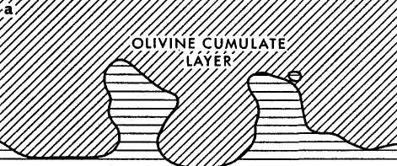

Tern

:calcite-rich:
LAYER

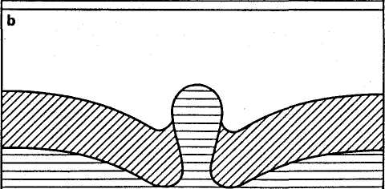

■,Г Г-Л

гНгтчг? in thf* T.owpr Sill

Jl geol. Soc. Lond. vol. 129, 1973
8OA
DAWSON & HAWTHORNE

Plate i

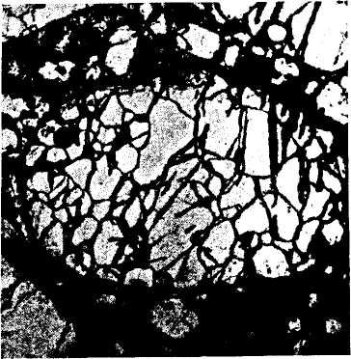
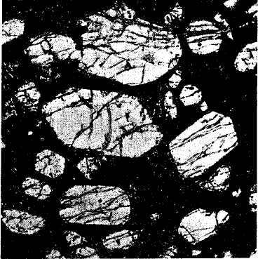

Idiomorphic olivines in fine-grained matrix of calcite, spinel/perovskite and apatite. Specimen BD 1054. Middle Sill. Plane polarized light,

X13.
В
Microxenoliths of xenomorphic olivines. Specimen BD 1613, Middle Sill. Plane polarized light, X13.

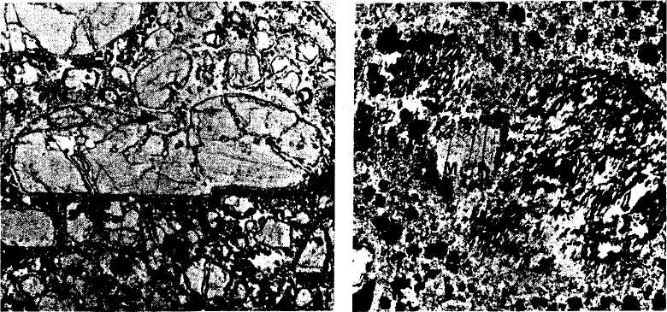

Microxenolith of xenomorphic olivines: during settling the xenolith has entrapped beneath it

D
A crystal of brown, corroded, xenomorphic mica (M) within a serpentinised microxenolith

OB

I geol. Soc. Lond. vol. 129, 1973
DAWSON & HAWTHORNE

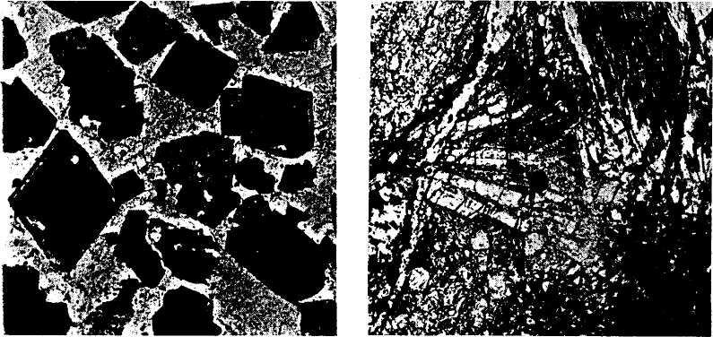

)paque spinel and perovskite in a calcite latrix. Note the overgrowth on some spinel rystals. Specimen BD 1617, Lower Sill. Plane olarized light, X 180.

В
Acicular apatite in coarse calcite patches. Specimen BD 1767, Upper Sill. Plane polarized light, X45.

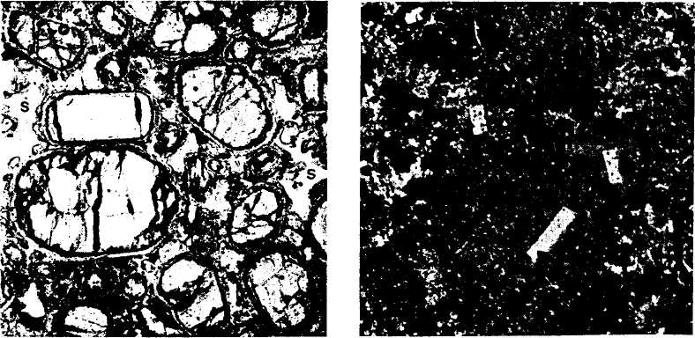
С D
ob'vmrs sot in xcnomorphir ml- Rnndomlv oriented groundmass micas. Note

Jl geol. Soc. Lond. vol. 129, 1973
80c
DAWSON & HAWTHORNE

Plate 3

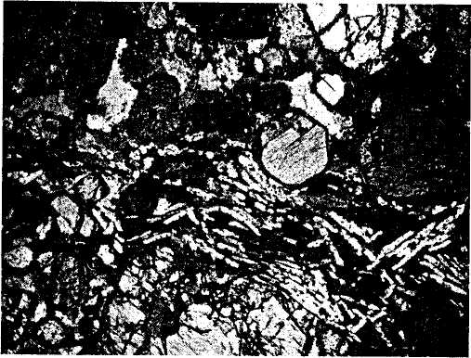
Trachytic texture due to preferred orientation of prismatic calcite crystals. Specimen BD 1055, Middle Sill. Crossed polarizers, X13.

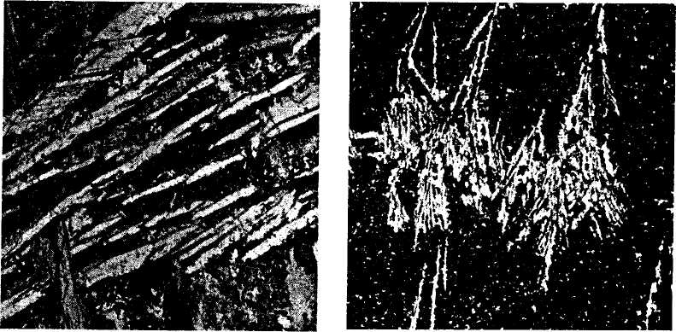

В

Acicular, skeletal crystals of calcite in a carbonate-rich layer. The individual crystals have the same optic orientation and may coalesce
Dendritic calcite growing downwards from a horizontal contact. The dendrites are relatively simple for a short distance from the contact.

80D
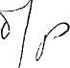
Jl geol. Soc. bond. vol. 129, 1973
Plate 4
DAWSON & HAWTHORNE

1cm.
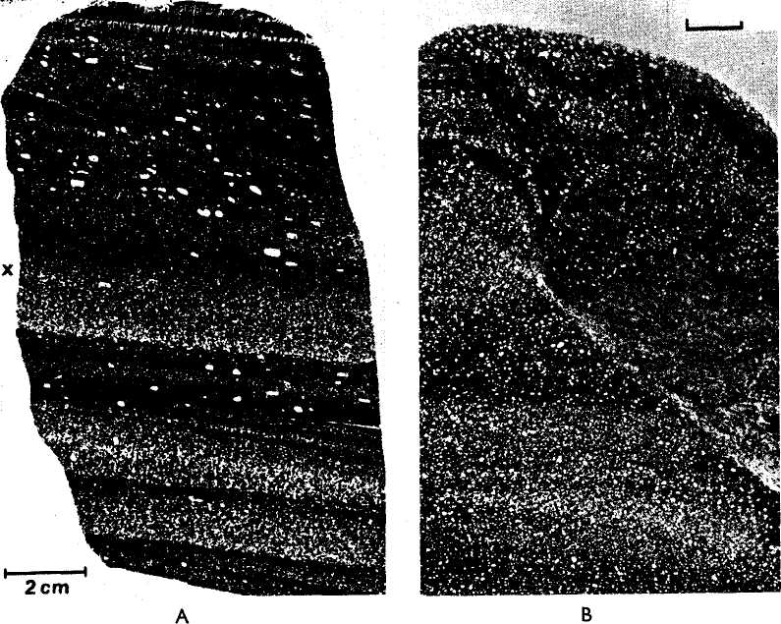

Layered kimberlite. Most layers are mineral graded, the best example being the layer marked x. Note the dendritic calcites at the top of the uppermost layer. Specimen BD 1051, Upper Sill.
Layered kimberlite, with isomodal layers truncated by a later unit rich in calcite. Specimen BD 1049, Upper Sill.
in

Thin sections of layered kimberlite illuminated from the rear. Light-coloured minerals are mainly olivine with subordinate amounts of calcite and apatite. The dark minerals are spinel and perovskite.

о
Л geol. Soc. bond. vol. 129, 1973
1
Г80У
DAWSON & HAWTHORNE Plate 4 continued

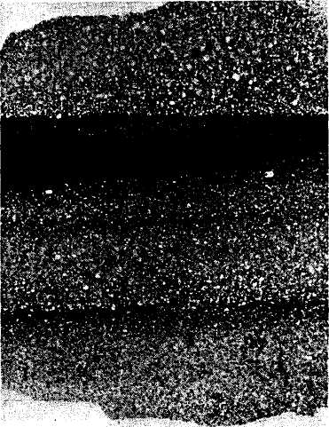
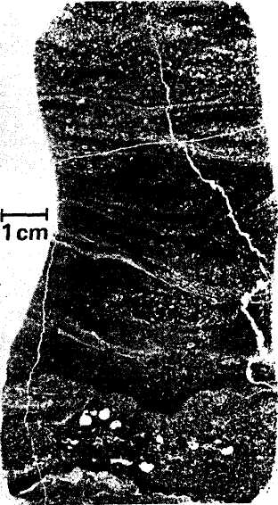
2cm

Layered kimberlite showing extreme enrichment in spinel and perovskite (dark minerals) in the upper part of the layer. Note the planar contact between layers. Specimen 1635, Middle Sill.
D
Calcite-rich kimberlite with micro-troue cross-lamination picked out by spinel an perovskite-rich bands. Load casting and fo mation of white spherules of clear calcite ai visible in the lower part of the sectio Specimen BD 1765, Upper Sill.

80П
Jl gkol. Soc. Lond. Vol. 129, I973 DAWSON & HAWTHORNE
Plate 5—on facing page
Asize-graded and mineral-graded layer. Larger olivines are concentrated in thelower part of the layer and spinel and perovskite are concentrated in the upper part. Dendritic calcite is present at the upper contact. Specimen BD 1655, Middle Sill.
Cross lamination in kimberlite. The light areas are mainly of olivine and the dark laminae are of spinel and perovskite. Specimen BD 1634, middle Sill.
80П
Л $ко1. Soc. Lond. vol. 129, 1973 dawson & hawthorne
Plate 5—on facing page
Asize-graded and mineral-graded layer. Larger olivines are concentrated in thelower 1^
part of the layer and spinel and perovskite are concentrated in the upper part. .5J
Dendritic calcite is present at the upper contact. Specimen BD 1655, Middle Sill.
Cross lamination in kimberlite. The light areas are mainly of olivine and the dark laminae are of spinel and perovskite. Specimen BD 1634, middle Sill.
80n
Jl gjkol. Soc. bond. vol. 129, 1973 dawson & hawthorne
Plate 5—on facing page
Asize-graded and mineral-graded layer. Larger olivines are concentrated in thelower 1^
part of the layer and spinel and perovskite are concentrated in the upper part. 5f
Dendritic calcite is present at the upper contact. Specimen BD 1655, Middle Sill.
Cross lamination in kimberlite. The light areas are mainly of olivine and the dark laminae are of spinel and perovskite. Specimen BD 1634, middle Sill.

Jl geol. Soc. bond. vol. i29₅ 1973
'80 x
DAWSON & HAWTHORNE

Plate 5
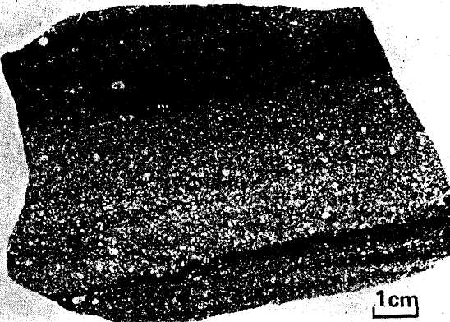
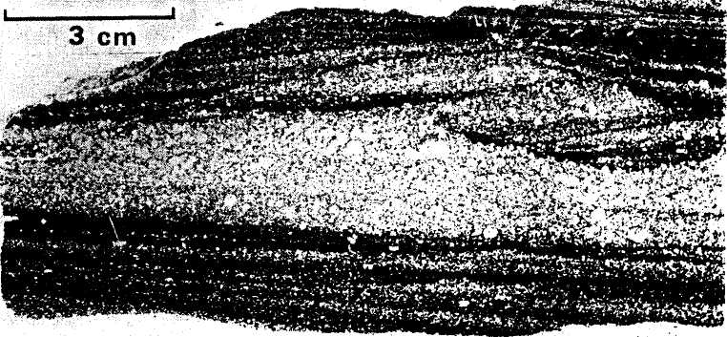

80ш
Jl'geol. Soc. bond. vol. 129, 1973 dawson & hawthorne
Plate 6—on facing page
Thin sections, illuminated from the rear, of the diapiric layer in the Lower 1
Sill. In Plates 6A, В and С the contact of the root-layer and rooted diapirs J
with the overlying dlivine cumulate layer has been inked in for emphasis. , |
The white areas are mainly of clear carbonate with minor quartz. The ч ■'
'lightness' of any area is generally a reflection of the calcite content. -*■
The unit consists basically of four layers: 1. the root layer; я. an olivine cumulate layer that is intensely intruded by rooted diapirs; 3. an overlying finer-grained olivine-magnetite cumulate layer; 4. a dense, dark-coloured magnetite-perovskite cumulate layer. The sequence is best seen in Plate 6D. In Plates 6A and В layer 4 has been injected between layers 2 and 3, and in Plate 6C the contact between layers 3 and 4 is blurred. The intrusion sequence was probably 3, 2, 1, 4.
Tabular or sphenoidal calcites are visible in the root-layers in all Plates, and overturn of cross laminae is seen in 6C. The contact between layers 1 and 2 is emphasised by dendritic calcites in 6B and D. Spherules of clear calcite are seen together with root-layer material in the rooted diapirs in 6A, B, and C, and clear carbonate diapirs originating in the root-layers are visible in all Plates. The detached diapirs consist mainly of clear carbonate with subsidiary quartz, but root-layer material may be seen in them (points 'x' Plate 6A), and magnetite is especially well seen in them in 6D. In 6A, B, and C, layer 4 has been intruded by detached diapirs, but in 6D it has been impervious to penetration. Upward bifurcation of the detached diapirs is well seen in 6A, and C, and development of calcite contact dendrites is par-
to
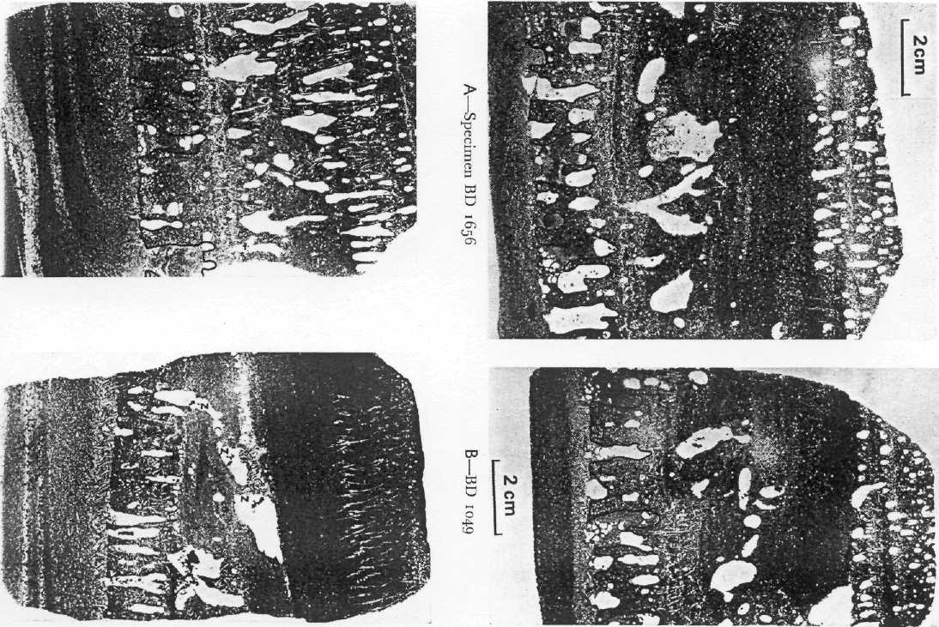
'.OF

4 geol'. Soc. Lond. vol. 129, 1973
DAWSON & HAWTHORNE U

'late 7
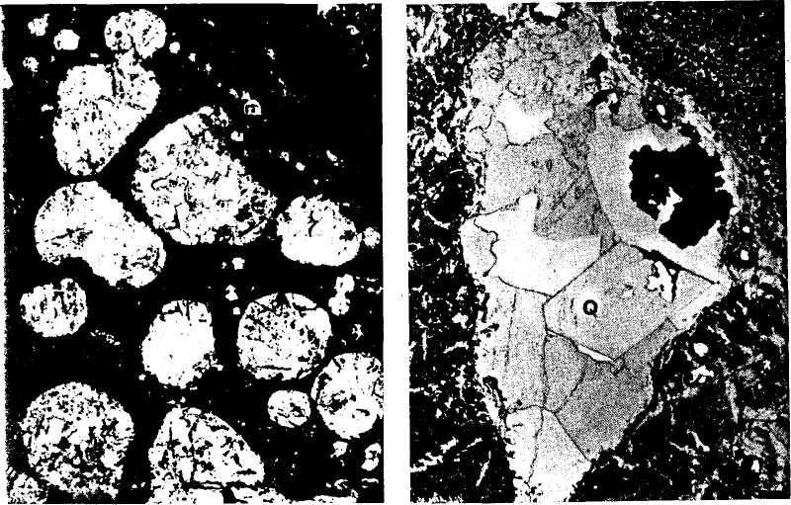
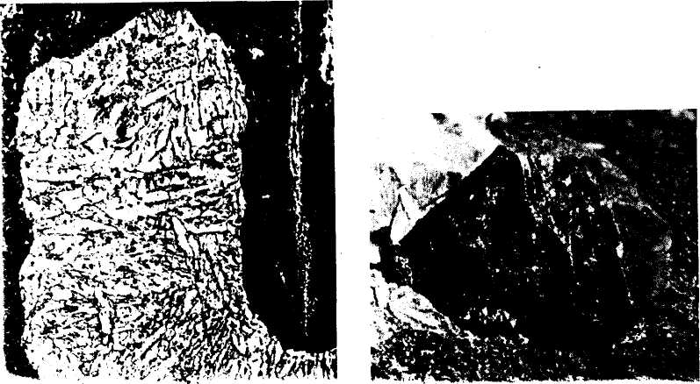

Jl geol. Soc. bond. vol. 129, 1973
80 R
DAWSON & HAWTHORNE

Sharply bounded spherules consisting mainly of clear calcite in turbid root-layer material in a rooted diapir. Specimen BD 1046, Lower Sill. Plane polarized light, X12.
В
A zoned detached diapir. A peripheral thin zone of rhombic dolomite encloses calcite, magnetite and quartz ('Q,'). Specimen BD 1614, Lower Sill. Plane polarized light, X 12.
Plate 7—on facing page
С
Platy calcites in a detached diapir. Specimen BD 1046, Lower Sill. Plane polarized light, XI2.
D
Photograph of twinned magnetite in detached diapir. The crystal is 8 mm long. Specimen BD 1060, Lower Sill.

geol. Soc. I.ond. vol. 129, 1973
DAWSON & HAWTHORNE

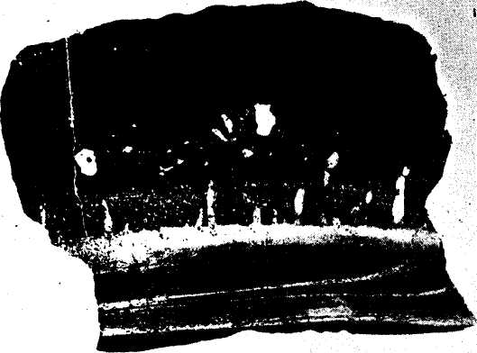
5cm

Layered diapiric unit from the Lower \ Sill, showing contortion due to loading JJ by the dark, dense spinel-perovskite * cumulate layer. Specimen BD 1047, ' Lower Sill.
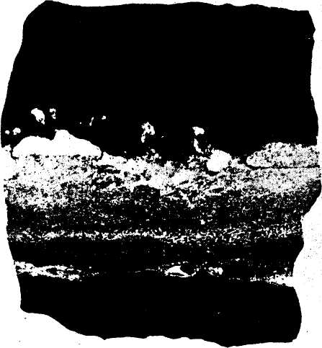
Б
Load casting and initiation of diapirism at contact between carbonate-rich layer and overlying olivine-cumulate layer. Note the concentration of clear calcite in the incipient diapir on the left-hand side of the specimen and the rlear calcite

Magmatic sedimentation and carbonatitic differentiation in kimberlite sills 81
deviant in oxygen but in carbon also. No firm explanation can be offered for this as the two samples are petrographically similar except that the calcite diapirs in BD 1049 tend to contain small rafted crystals of serpentinized olivine which may have affected the values.
7. Conclusions
1. The kimberlite sills at Benfontein were formed by a large number of repeated injections of small amounts of kimberlite that consolidated in thin tabular sheets or layers. The fluid contained microxenoliths of dunite and phlogopite-bearing dunite, and xenocrysts of pyrope garnet, phlogopite, forsterite olivine, and chrome-diopside that may be have been derived by the break-up of garnet lherzolite. In addition it contains megacrysts of picroilmenite, and euhedral zoned crystals of olivine not derived from lherzolite, together with smaller crystals of spinel, perovskite, apatite and diamond.
- All these crystals were transported in a fluid which solidified mainly as
calcite with very minor quantities of dolomite, ankerite, magnetite, serpophite,
phlogopite and quartz. The fluid imposed minor thermal effects upon the wall
rock and inclusions, and quench calcite and apatite formed during cooling.
- During intrusion a wide variety of magmatic sedimentary structures and
textures were formed. The presence of cumulate textures, in situ settling features,
zoned diapiric structures and load casting, combined with the quench calcites
and metamorphism, is taken as evidence that the transporting fluid was a
moderately hot liquid.
- Layers rich in the transporting calcite-rich fraction were formed by in situ
differentiation, and calcite-rich and spinel-perovskite-rich fractions were also

                - U «О

-3 | 4 Benfontein samples BD1049 ф Oka "box" (Conway and Taylor, 1969)
 | t |  | 4 BD 1640/1
 | t |  | 1  ♦"BD1048
-7 | ■ | BD1726 К | 4 4 4 BD 1640/2 BD 1640/3
-О | Probable field of primary igneous carbonatite (Taylor etal., 1967)  1 1 1 1 1 1 1 1 1 1

8i J. В. Dawson & J. B. Hawthorne
formed prior to intrusion. The differentiation processes at Benfontein have concentrated minerals that are generally widely dispersed throughout the ground-mass of kimberlite.
5. From their textures, trace element geochemistry, and oxygen and carbon ' isotope geochemistry, the carbonate layers may be classified as carbonatites. U The Benfontein data reinforce the assertions of Brookins (1967) and Brookins & > Watson (1969) who, on the basis of strontium isotope evidence from kimberlites in Kansas and Quebec, have proposed that kimberlite calcite is carbonatitic in character.
' Apart from^ interesting features such as the presence of zoned olivine, the evidence of small-scale diapirs, and possible liquid immiscibility, we feel that the Benfontein study contributes significantly to two fundamental points of kimberlite geology. Various authors have proposed that kimberlite is emplaced into the crust from depths of 150 km either a cold fluidised mass (Davidson 1964; Kennedy & Nordlie 1968) or as a cold diapiric paste (Mikeyenko & Nenashev 1961). The evidence from Benfontein, that kimberlite was a warm liquid at depths of no more than 1,600 metres below the land surface at the time of its intrusion, is directly opposed to these earlier proposals. It does however raise the problem of transporting diamond to the surface from its point of origin in the upper mantle in a medium that would strongly favour its resorption; cold transportation would preclude this problem and hence has held great appeal for the proponents of the 'cold' hypotheses. However, diamond will only be strongly resorbed if the pressure drops, and the implication is that high pressures were maintained up to high levels in the crust. The second feature is that the Benfontein evidence is relevant to the problem of the relationship between kimberlites and carbonatites. Earlier proposals that kimberlite and carbonatite are genetically associated (e.g. Saether 1957; von Eckermann 1967; Dawson 1967) have recently been severely criticised by Mitchell (1970) who states ^{c}a stronger case might be made for the association between kimberlite and basalt' {op. cit. p. 700). The Benfontein data, combined with the Sr isotope data, favour the earlier proposals to the extent that both kimberlites and carbonatites contain appreciable amounts of high-temperature calcite that is distinguished from calcite of hydrothermal or sedimentary origin by its morphology, trace element content, and carbon and oxygen isotope ratios.
acknowledgements. Our work at Benfontein was carried out with the permission and encouragement of Dr. L. G. Murray, of the Anglo-American Corporation of South Africa, and Mr. C. D. Hallam, former Chief Geologist of the De Beers Consolidated Mines Ltd., and J. B. D. wishes in addition to thank Mr. & Mrs. Hallam for help and hospitality during his visit to Kimberley in 1969. The cost of extra plates was met by De Beers Consolidated Mines Ltd.
Dr. С. Н. Emeleus carried out a large number of mineral analyses at the University of Durham, by kind permission of Professor G. M. Brown, and other microprobe analyses were made at the British Museum of Natural History by Drs. R. Hutchison and R. F. Symes. The bulk rock analyses were carried out by Miss J. R. Baldwin and Mr. D. G. Powell, University of St. Andrews, and
■' * ч»<; \vrrr '''-^{f}'ч-^'ч' <* Ь-- J^*- О т-мтт 7\-] ?>t tbr* Ann-tn-Amrrirnrt Rr^nrrh T,nbnr-
Magmatic sedimentation and carbonatitic differentiation in kimberlite sills 8
The paper has benefited from discussions with Dr. J. Harris and Professor E. K. Walton, уЛ gave considerable guidance on the sedimentation aspects. The text-figures were drawn by M P. J. Clarke of the St. Andrews University Cartographic Service. The analytical work at S Andrews, and travel and field work in South Africa (J. B. D.) was supported by a grant from tli Natural Environment Research Council.
8. References
Andrews, J. R., & Emeleus, С. Н. 1971. Preliminary account of kimberlite intrusions from tb<
Frederikshab district, South-West Greenland. Rep. geol. Surv. Greenland 31. Bowden, P. 196a. Trace elements in Tanganyika carbonatites. Nature Land., 196, 570. Brookins, D. G. 1967. The strontium geochemistry of carbonates in kimberlites and limestone*
from Riley County, Kansas. Earth Planet Set. Letters, 2, 235-240.
& Watson, K. D. 1969. The strontium geochemistry of calcite associated with kimberlite
at Bachelor Lake, Quebec. J. Geol. 77, 367-371. Conway, C. M., & Taylor, H. P. 1969. O¹⁸/O^{w} and С¹³/⁰" ratios of coexisting minerals in
the Oka and Magnet Cove carbonatite bodies. J. Geol. 77, 618-626. Davidson, C. F. 1964. On diamantiferous diatremes. Econ. Geol. 59, 1368-1380. Dawson, J. B. i960. A comparative study of the geology and petrography of die kimberlites of the
Basutoland province. Unpubl. Ph.D. thesis, University of Leeds.
1962a. Basutoland kimberlites. Bull. geol. Soc. Am. 73, 545-560.
1962b. The geology of Oldoinyo Lengai. Bull. Volcan. 34, 349-387.
1967. Geochemistry and origin of kimberlite iin P. J. Wyllie (Ed.), Ultramafic and related
rocks New York, 269-278.
& Gale, N. H. 1970. Uranium and thorium in alkalic rocks from the active carbonatite
volcano Oldoinyo Lengai (Tanzania). Chem Geol. 6, 221-231.
■ & Hawthorne, J. B. 1970. Intrusion features in some hypabyssal South African kimberlites.
Bull. Volcan. 34, 740-757. Du Torr, A. L. 1906. Geological survey of the eastern portion of Griqualand West. Rep. geol.
Commn Cape Good Hope 11, 87-176. Dzulynski, S. & Walton, E. K. 1965. Sedimentary features offlysch and greywackes. Amsterdam
(Elsevier) Eckermann, H. von. 1961. The petrogenesis of the Alno alkaline rocks. Bull. geol. Instn Univ.
Upsala, 40, 25-36.
1967. A comparison of Swedish, African and Russian kimberlites. in P. J. Wyllie (Ed.),
Ultramafic and related rocks. New York. 302-312. Elder, J. W. 1970. Quantitative laboratory studies of dynamic models of igneous intrusions, in
G. Newall & N. Rast (Eds). Mechanism of igneous intrusion, 245-260. Girault, J. 1966. Genese et geochimie de Г apatite et de la calcite dans les roches liees au com-
plexe carbonatitique et hyperalkalin d'Oka (Canada). Soc. Frang. Mineral Bull. 84, 496-513. Gittins, J. 1963. Further evidence for the existence of carbonatite magmas. Can. Mineralogist
7.817. Goles, G. G. 1967. Trace elements in ultramafic rocks, in P. J. Wyllie (Ed), Ultramafic and related
rocks. New York, 352-362. Hawthorne, J. B. 1968. Kimberlite sills. Trans, geol. Soc. S. Afr. 71, 291-311.
(in press). Model of a kimberlite pipe. Trans, geol. Soc. S. Afr.
Jackson, E. D. 1967. Ultramafic cumulates in the Still water, Great Dyke and Bushveld intrusions.
in P. J. Wyllie (Ed), Ultramafic and related rocks. New York, 20-38. Johnson, R. L. 1961. The geology of the Dorowa and Shawa carbonatite complexes, Southern
Rhodesia. Trans, geol. Soc. S. Afr. 64, 101-145.
Kennedy, G. C. & Nordlie, В. Е. 1968. The genesis of diamond deposits. Econ. Geol. к-, ю- -^« Kharkiv. A. D. rnfv7. Tn^"- - "^{r}'-! '
8^ J. В. Dawson & J. В. Hawthorne
Mackenzie, О. Б. & White, A. J. R. 1970. Phonolite globules in basanite from Kiandra,
Australia. Lithos 3, 309-317. Me Call, G. J. H. 1963. A reconsideration of certain aspects of the Rangwa and Ruri carbonatite
complexes in western Kenya. Geol. Mag. 100, 181-185.
Mikeyenko, V. I. & Nenashbv, N. I. 1961. Absolute age of specimens and relative age of emplacement of kimberlites in Yakutia. Transactions gth Session Committee on Absolute Age, Acad.
Set. U.S.S.R. 146-164. Milledge, J. Б. & Dawson, J. B. (in preparation) Uranium and thorium in South African
kimberlites.
Mitchell, R. H. 1970. Kimberlite and related rocks—a critical reappraisal. J. Geol. 78, 686-704. Nixon, P. H., Knorring, O. von & Rooke, J. 1963. Kimberlites .and associated inclusions of
Basutoland: a mincralogical and geochemical study. Am. Miner. 48, 1090-1132. Ramberg, H. 1970. Model studies in relation to intrusion of plutonic bodies in G. Newall & N.
Rast (Eds), Mechanism of igneous intrusion, 261-286. Saether, E. 1957. The alkaline rock province of the Fen area in southern Norway. Norsk.
Vidensk. Selsk. Skr\ft. 1, 1-150. , v^{J}
Saffman, P. G. & Taylor, G. I. 1958. The penetration of a fluid into a porous medium or
Hele-Shaw cell containing a more vbcous fluid. Proc. R. Soc. 245A, 312-329. Saratovkin, D. D. 1959. Dendritic crystallisation. New York (Consultants Bureau). Shand, S. J. 1934. The heavy minerals of kimberlite. Trans geol. Soc. S. Afr. 37, 57-68. Smith, R. E. 1967. Segregation vesicles in basaltic lava. Am. J. Sci. 265, 696-713. Stewart, J. W. 1970. Precambrian alkaline-ultramafic/carbonatite volcanism at Qagssiarssuk,
south Greenland. Meddr Grenland 186, No. 4. Taubeneck, W. H. & Poldervaart, A. i960. Geology of the Elkhorn mountains, north-eastern
Oregon. 2-Willow Lake intrusion. Bull. Geol. Soc. Am. 71, 1295-1322. Taylor, H. P., Frechen, J. & Degens, E. T. 1967. Oxygen and carbon isotope studies of car-
bonatites from the Laacher See district, West Germany, and the Alno district, Sweden.
Geochim. cosmochim. Ada 31, 407-430. Verwoerd, W. J. 1966. South African carbonatites and their probable mode of origin. Annals
Univ. Stellenbosh 41, Ser. A, 115-233. Vorr, F. W. 1907. Further remarks on the kimberlite rock and the origin of diamonds. Trans.
geol. Soc. S. Afr. 10, 101-106.
Wager, L. R. & Brown, G. M. Layered igneous rocks. Edinburgh (Oliver & Boyd). Wagner, P. 1914. The diamond fields of southern Africa. Johannesburg (Transvaal Leader). Williams, G. С 1939. The kimberlite province and associated diamond deposits of Tanganyika
Territory. Bull. geol. Surv. Tanganyika 13. Wyllie, P. J. & Tuttle, O. F. i960. The system GaO—CO_{S}—H_{a}O and the origin of carbonatites.
J. Petrology 1, 1-46.
, Cox, K. G. & Bigoar, G. M. 1962. The habit of apatite in synthetic and igneous systems.
J. Petrology. 3, 238-243.
• & Boettcher, A. L. 1969. Liquidus phase relationships in the system CaO—CO₂—H2O
to 40 kilobars pressure, with petrological applications. Am. J. Sci. 267-A, 489-508. Zhabin, A. G. & Cherepvskaya, G. Y. 1965. Carbonatite dykes as related to ultrabasic-alkalic extrusive igneous activity. Dokl. Acad. Sci. U.S.S.R. Earth Sci. Sect. 160, 135-138.
Manuscript received 23 August 1971; revised manuscript received 12 April -1972; read 15 March 1972.
J. B. Dawson, b.sc, ph.d, d.sc, f.o.s.
Department of Geology, University of St. Andrews, Scotland.
Magmatic sedimentation and carbonatitic differentiation in kimberlite sills 6
DISCUSSION
Dr. M. J. Le Bas said he had two questions.
i i. Is this occurrence of a layered kimberlite sill with intercumulus calcit
ц unique?
£ 2. The calcite which forms 10 to 20% of this sill is stated by the authors to b genetically linked with carbonatite. Whilst many of the petrological and geo chemical features support this, no account has been made in the surrounding rocks of any marginal fenitization, which is the 'hall mark' of carbonatites and i: normally shown by the metasomatic growth of K-feldspar, aegirine or Na-amphibole. Is there any such fenitization?
The Authors replied that to the best of their knowledge the Benfontein kimberlite sill is unique. Magmatic sedimentation features are known in the kimberlite sills (e.g. those in S. W. Greenland) but the fine-scale layering, concentration oi intercumlus calcite in the upper parts of layers, and the small-scale diapirism, have not been recorded in kimberlite previously.
2. Whilst not being 'fenitisation' in the generally accepted sense, potassium metasomatism is known in many kimberlite intrusions. This is mainly manifested in the form of phlogopitisation of the basic and ultrabasic xenoliths, though classical potassium fenitisation is known at the contacts of a kimberlite dyke in the Seguela River area of the C6te d'lvoire. In the specific case of the Benfontein sills, metasomatic mica is developed in the peripheral parts of some dolerite xenoliths.

